# USER MANUAL

### Introduction

Mainly, this product was made to achieve the following:

1. Stopwatch display (Hh.Mm.Ss form)
2. Reset button
3. Stop button
4. Resume button

But the following features were added lately:

1. Clock Setting Buttons
2. Overflow Indicator
3. Mode Swap (Stopwatch/Clock)
4. Alarm system
5. 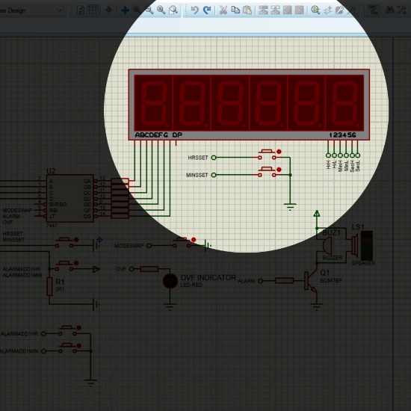Developer Mode

### Stopwatch Display

Multiplexed technique was used to display the time passed, whenever the power reaches the system, it will start counting calculating the time.

### Reset Button

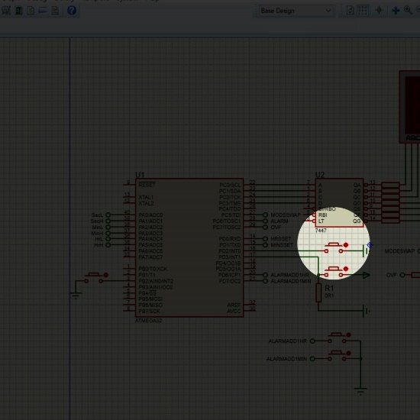 Using external interrupt 0, system supports resetting the stopwatch and clearing the supported feature, so if you had set alarm and you clicked on the button, alarm will be canceled, same with the mode swap option, if you converted the counter to the clock mode and clicked reset, the watch will back to work as a stopwatch.

### Stop Button

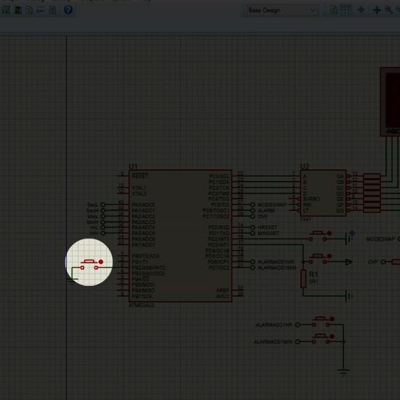 If you clicked on the stop button, independent of the mode you chose, the display will be fixed on the certain time you clicked on the button at until you click on the resume or reset button, but it is preferred to use the resume button.

1. **Resume Button**

If you clicked here, nothing will happen unless you had clicked on the stop button before it, it will let the display continue counting.

1. 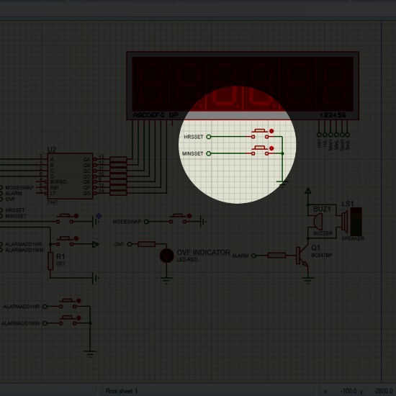**Clock Setting Buttons**

Using these buttons, you will be able to adjust the hours and minutes to set it to the preferred time.

### Overflow Indicator

This LED will be ON if the system reached the overflow, to indicate that: in stopwatch mode you have passed the maximum of it, which is 99:59:59 (100 Hours), and in clock mode, 11:59:59 (12 Hours) passed.

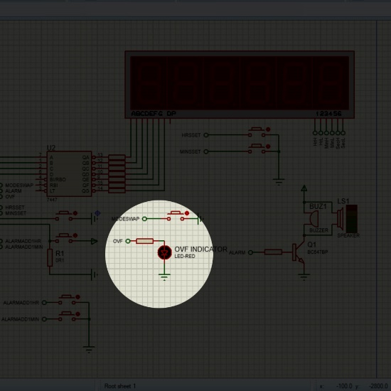

### Mode Swap Button

This button enables you to swap between stopwatch mode which counts to 100 hours and clock mode which counts to 12 hours as maximum, if you were working on stopwatch mode and clicked the button, the display will show you the equivalent hour, if it is not the right time, you can adjust it using clock setting buttons.

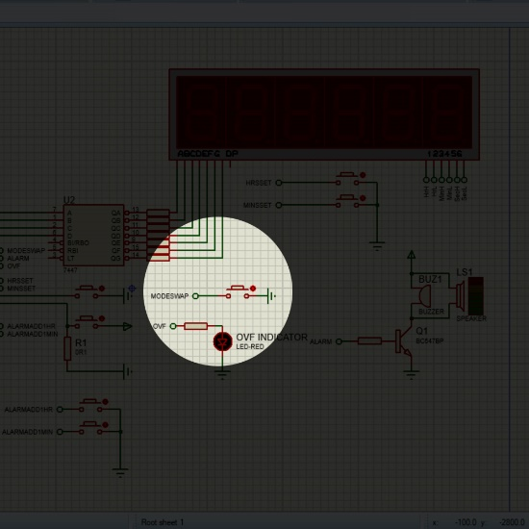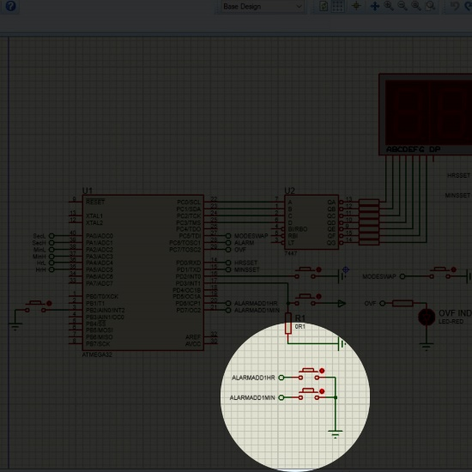

### Alarm System

Using the two buttons in the next screenshot, you can enjoy real stopwatch functionality, as you can set alarm for 1 minute, 2, more if you want just by clicking the button of minutes for n times; where n is the number of minutes you want, and you can do the same with hours, which means you can enjoy the certain time you want. For example if you want to set a stopwatch for 10 minutes, all you have to do is to click on ALARMADD1MIN for 10 times, after 10 minutes, the buzzer system will wake the worst of you for 10 seconds, which can be changed in Developer mode, for your mental health, 3 seconds maximum is recommended.

1. **Developer Mode**

Getting your hand dirtier inside the C code will give you access to set Alarm using code, or force the system to work on clock mode, or the best of them you can change the alarming time to reduce the pain.